**Day 31 Lab questions**

#1. WAP to create an array that can store max. 5 integers and display the contents of the array

Code:

#include <stdio.h>

int main()

{

    int i285, arr285[5];

    printf("Please provide 5 positive integers\n");

    for(i285=0;i285<=4;i285++)

    {

        scanf("%d",&arr285[i285]);

        printf("Element %d is %d\n",i285,arr285[i285]);

    }

    return 0;

}

Output:

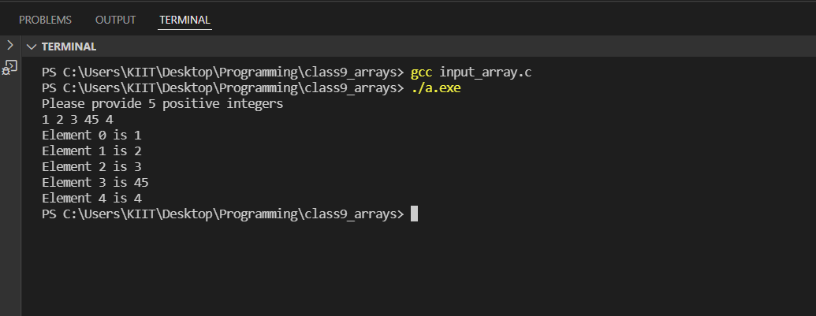

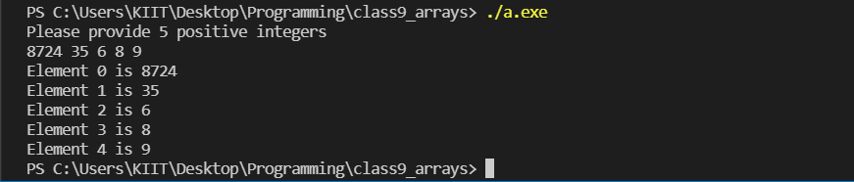

#2. WAP to find out the sum of the numbers stored in an array of 5 integers.

Code:

#include <stdio.h>

int main()

{

    int sum285,i285;

    int arr285[5];

    printf("please give 5 positive integers\n");

    for(i285=0;i285<=4;i285++)

    {

        scanf("%d",&arr285[i285]);

    }

    for(i285=0;i285<=4;i285++)

    {

        sum285 = sum285 + arr285[i285];

    }

    printf(" The sum of the integers is %d",sum285);

    return 0;

}

Output:

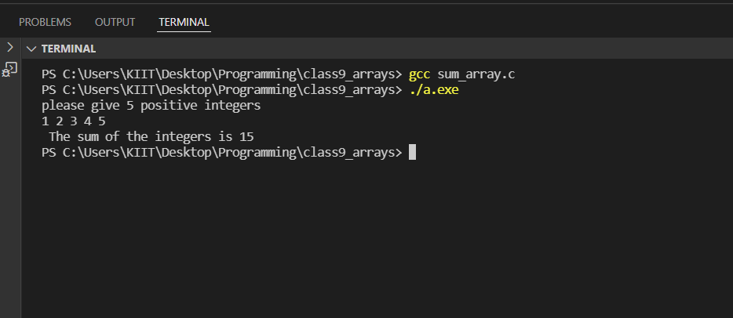

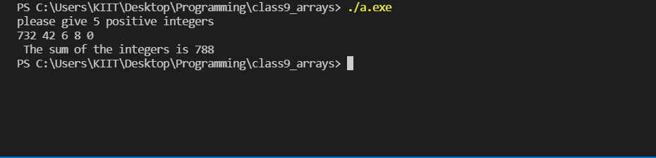

#3. WAP to display elements in reverse order of an array that can store 5 integers.

Code:

#include <stdio.h>

int main()

{

    int i285,arr285[5];

    printf("Please provide 5 integers\n");

    for(i285=0;i285<5;i285++)

    {

        scanf("%d",&arr285[i285]);

    }

    for(i285=4;i285>=0;i285--)

    {

        printf("Element %d is %d \n",i285,arr285[i285]);

    }

    return 0;

}

Output:

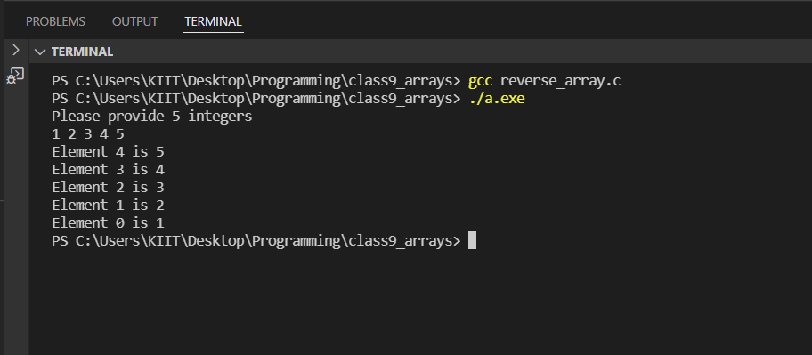

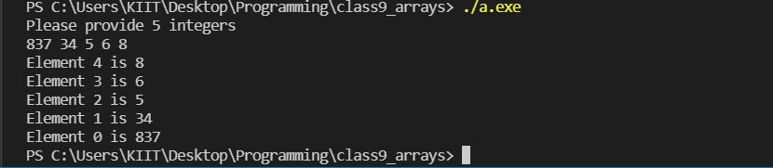

#4. WAP to write an array of size 50 and read n (n < 50) elements and display the content.

Code:

#include <stdio.h>

int main()

{

    int a_285[50],i_285,n_285;

    printf("\nEnter the range:");

    scanf("%d",&n_285);

    printf("\nEnter values for the array: ");

    for(i_285=0; i_285<n_285; i_285++)

    scanf("%d",&a_285[i_285]);

    printf("\nThe elements are:");

    for(i_285=0; i_285<n_285; i_285++)

    printf("%d \t",a_285[i_285]);

    return 0;

 }

Output;

